Phase 5

Day 1 :

11-04-2022

Total 10 classes (one two hours)

Testing and deployment

TestNG (next generation on testing ) like jUnit

Selenium Automation tool to test the application

Docker

Kubernetes Overview

Cloud computing and AWS Overview EC2 and S3

Component communication

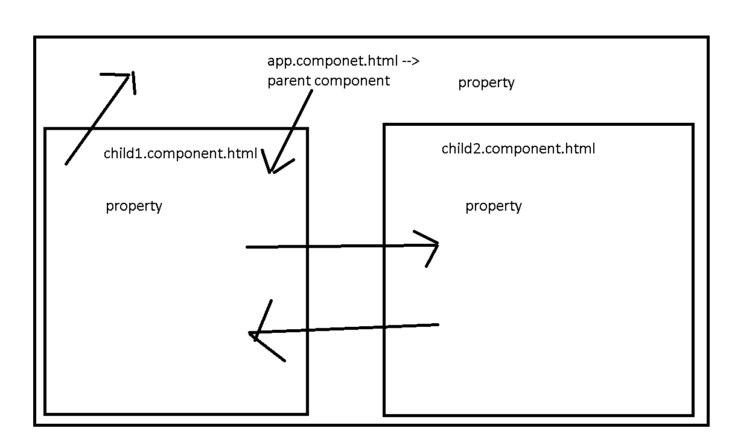

Ng new component-communication

Routing -🡪 no

Styling 🡪 css

Create two component using command as ng

ng g c child1

ng g c child2

ng g s shared

Share the data between component communication

1. Parent – child : using @Input decorator we can share the data from parent to child.
2. Child – Parent :
   1. Using @Output with EventEmitter API we can share the data between child to parent.
   2. Using @ViewChild we can share the data between child to parent.
3. Sibling :
   1. Using sessionStorage and localStorage : HTML5 and JavaScript features.
   2. Shared service class : using Angular features
   3. Using RxJS with Observable we can share the data.

Angular Routing

Ng new angular-routing

Routing -🡪 Yes

Styling 🡪 css

Angular routing is use to move from one component html page to another component html without loading whole page.

It is use to navigate from one component to another component base path provided in routing file.

Ng g c aboutus

Ng g c contactus

Ng g c feedback

Ng g c login

Ng g c home

Angular provided pre-defined ie <router-outlet></router-outlet>

This tag behave like a place holder. Which load the component html code base upon the path provided in routing file.

Day 2 :

12-04-2022

jUnit Testing 4.x and 5.x

TestNG

Unit testing : unit testing is use to test function functionality working property or not.

We write the set of code inside method or function.

Junit in Java

Nunit in asp.net

Angular framework is use Jasmine

React JS JEST

jUnit 5 version support Java 1.8 features.

jUnit 5 is a combination of multiple modules

jUnit 5 = Junit platform + Junit Jupiter + Junit vintage

Mock the object or create fake object or proxy object.

Controller layer depends upon the service layer

Service layer depends upon the dao layer

Dao layer depends upon the resource layer

Resource layer depends upon on the resources ie database.

Controller layer create the mock object of service layer

Service layer create the mock objet of dao layer

To do mocking concept

jMockito is a open source API or framework. We can use with jUnit to achieve mocking concept.

Day 3 :

13-04-2022

TestNG : Test NG is testing open source framework inspired by jUnit and nUnit. It provided some new functionality that makes more power full and easier to use.

Test NG : Next Generation

Next generation on testing.

Test NG mainly use to do integration testing.

Features

1. It generate HTML reports
2. It provided lot of different types of annotation. So we can run more than one test case in group and priority.
3. Parallel testing case achieve using TestNG
4. Generate the logs. (We can store the execution of a program).

@Test it is same like jUnit 4.x or 5.x

@BeforeMethod it is equal to @BeforeEach

@AfterMethod it is equal to @AfterEach

@BeforeClass it is equal to @BeforeAll

@AfterClass it is equal to @AfterAll

Test suite : it is use to run more than one test case class. every test case class contains more than one test function.

In jUnit testing we run test suite using class but in TestNG we run using xml file.

CarTest

carLoan

carColor

carPrice

BikeTest

bikeLoan

bikeColor

bikePrice

vehiclesuite.xml

file responsible to run two test cases class with 6 test method.

TestNG group

TestNG priority

TestNG Report